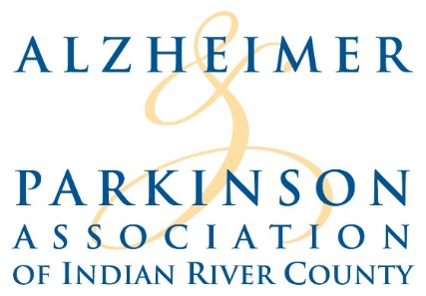
2019 TEAM CAPTAIN GUIDE
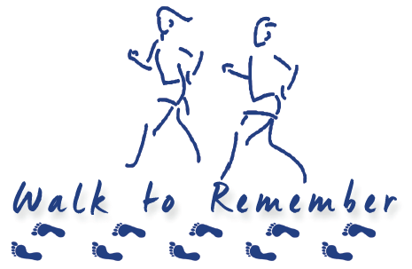
SATURDAY, NOVEMBER 12, 2016
RIVERSIDE PARK

www.walktoremembervero.org

SATURDAY, NOVEMBER 9, 2019 – RIVERSIDE PARK
7:30 AM REGISTRATION OPEN
8:30 AM PROGRAM
9:00 AM WALK BEGINS!

WWW.WALKTOREMEMBERVERO.ORG
This guide provides information to help you in your role
as a Team Captain from now until November 9, 2019!
ABOUT THE WALK TO REMEMBER

The 16th annual WALK TO REMEMBER is the Alzheimer & Parkinson Association of IRC’s signature event for fundraising and awareness-building. Every dollar raised by the WALK TO REMEMBER stays right here in Indian River County, supporting vital programs that serve people with memory and/or motion disorders and their caregivers. Programs include social and in-home respite, support groups, caregiver training, Project Lifesaver tracking bracelets and guidance, memory screenings, light exercises for people with Parkinson’s including balance, yoga and Tremble Clefs, Qigong classes, art classes, and “land and sea” on the ground and water movement classes in a heated indoor therapy pool at The Brennity, and a Movement at the Museum program at the Vero Beach Museum of Art.
Creating a “Dementia Friendly Community” is an ongoing initiative, made possible by a grant from Indian River County Impact 100. A dementia-friendly community is a place where people living with dementia are supported to live a high quality life with meaning, purpose, and value. The Dementia Friendly Community Initiative includes use of a mobile unit that serves as a rolling classroom.

The mission of the Alzheimer & Parkinson Association of IRC is to serve county residents with disorders affecting memory and movement by promoting quality of life and choice through advocacy, support, empowerment, education and research connections.

